**Project No. 1: Mercedes-Benz Greener**

**Manufacturing**

Step1: Importing library

import numpy as np

import pandas as pd

from sklearn.model_selection import train_test_split

from sklearn import preprocessing

Step2: Read the data from train.csv

train_df = pd.read_csv('train.csv')

test_df = pd.read_csv('test.csv')

# Find Number of rows and columns

print(train_df.shape)

print(train_df.columns)

# Find Number of rows and columns

print(test_df.shape)

print(test_df.columns)

# Describe the dataset

train_df.describe()

Step3: If any column(s) has the variance equal to zero, then you need to remove those variable(s)

train_df.var()

(train_df.var() == 0)

(train_df.var() == 0).values

variance_with_zero = train_df.var()[train_df.var()==0].index.values

variance_with_zero

# Drop zero variance variables

train_df = train_df.drop(variance_with_zero, axis=1)

print(train_df.shape)

train_df = train_df.drop(['ID'], axis=1)

train_df.head()

Step4: Check for null and unique values for test and train sets.  
train_df.isnull().sum().values  
train_df.isnull().any()  
test_df.isnull().sum().values

# Find unique records  
train_df.nunique()

Step5: Filter out the columns having object datatype

object_datatypes = train_df.select_dtypes(include=[object])

object_datatypes

object_datatype_columns = object_datatypes.columns

object_datatype_columns

Step6: Apply label encoder.

label_encoder = preprocessing.LabelEncoder()

train_df['X0'].unique()

train_df['X0'] = label_encoder.fit_transform(train_df['X0'])  
train_df['X0'].unique()

# Apply same for all columns having object type data

train_df['X1'] = label_encoder.fit_transform(train_df['X1'])

train_df['X2'] = label_encoder.fit_transform(train_df['X2'])

train_df['X3'] = label_encoder.fit_transform(train_df['X3'])

train_df['X4'] = label_encoder.fit_transform(train_df['X4'])

train_df['X5'] = label_encoder.fit_transform(train_df['X5'])

train_df['X6'] = label_encoder.fit_transform(train_df['X6'])

train_df['X8'] = label_encoder.fit_transform(train_df['X8'])

train_df.head()

Step7: Perform dimensionality reduction (PCA)

from sklearn.decomposition import PCA

sklearn_pca = PCA(n_components=0.95)

sklearn_pca.fit(train_df)

x_train_transformed = sklearn_pca.transform(train_df)

print(x_train_transformed.shape)

sklearn_pca_98 = PCA(n_components=0.98)

sklearn_pca_98.fit(train_df)

x_train_transformed_98 = sklearn_pca_98.transform(train_df)

print(x_train_transformed_98.shape)

train_df.y

Step8: Train and Test split on Train dataset

X = train_df.drop('y', axis=1)

y = train_df.y

xtrain,xtest,ytrain,ytest = train_test_split(X,y,test_size=0.3,random_state=42)

print(xtrain)

print(xtrain.shape)

print(ytrain)

print(ytrain.shape)

print(xtest)

print(xtest.shape)

pca_xtrain = PCA(n_components=0.95)

pca_xtrain.fit(xtrain)

pca_xtrain_transformed = pca_xtrain.transform(xtrain)

print(pca_xtrain_transformed.shape)

pca_xtest = PCA(n_components=0.95)

pca_xtest.fit(xtest)

pca_xtest_transformed = pca_xtest.transform(xtest)

print(pca_xtest_transformed.shape)

print(pca_xtest.explained_variance_)

print(pca_xtest.explained_variance_ratio_)

Step9: PCA for test_df dataset

test_df

test_object_datatypes = test_df.select_dtypes(include=[object])

test_object_datatypes

test_df['X0'] = label_encoder.fit_transform(test_df['X0'])

test_df['X1'] = label_encoder.fit_transform(test_df['X1'])

test_df['X2'] = label_encoder.fit_transform(test_df['X2'])

test_df['X3'] = label_encoder.fit_transform(test_df['X3'])

test_df['X4'] = label_encoder.fit_transform(test_df['X4'])

test_df['X5'] = label_encoder.fit_transform(test_df['X5'])

test_df['X6'] = label_encoder.fit_transform(test_df['X6'])

test_df['X8'] = label_encoder.fit_transform(test_df['X8'])

print(test_df)

print(test_df.shape)

test_df = test_df.drop('ID',axis=1)

pca_test_df = PCA(n_components=0.95)

pca_test_df.fit(test_df)

pca_test_df_transformed = pca_test_df.transform(test_df)

print(pca_test_df_transformed.shape)

print(pca_test_df.explained_variance_)

print(pca_test_df.explained_variance_ratio_)

Step10: Training using xgboost

test_df = pd.read_csv('test.csv')

usable_columns = list(set(train_df.columns) - set(['ID', 'y']))

ytrain = train_df['y'].values

id_test = test_df['ID'].values

xtrain = train_df[usable_columns]

xtest = train_df[usable_columns]

for column in usable_columns:

    cardinality = len(np.unique(xtrain[column]))

    if cardinality == 1:

# Column with only one value is useless so we drop it

        xtrain.drop(column, axis=1)

        xtest.drop(column, axis=1)

    if cardinality > 2:

# Column is categorical

        mapper = lambda x: sum([ord(digit) for digit in x])

        xtrain[column] = xtrain[column].apply(mapper)

        xtest[column] = xtest[column].apply(mapper)

xtrain.head()

Step11: Perform xgboost

import xgboost as xgb

from sklearn.metrics import r2_score

from sklearn.model_selection import train_test_split

xtrain, xvalid, ytrain, yvalid = train_test_split(xtrain, ytrain, test_size=0.2, random_state=4242)

d_train = xgb.DMatrix(xtrain, label=ytrain)

d_valid = xgb.DMatrix(xvalid, label=yvalid)

d_test = xgb.DMatrix(xtest)

params = {}

params['objective'] = 'reg:linear'

params['eta'] = 0.02

params['max_depth'] = 4

def xgb_r2_score(preds, dtrain):

    labels = dtrain.get_label()

    return 'r2', r2_score(labels, preds)

watchlist = [(d_train, 'train'), (d_valid, 'valid')]

clf = xgb.train(params, d_train, 1000, watchlist, early_stopping_rounds=50, feval=xgb_r2_score, maximize=True, verbose_eval=10)

Step12: Predict test_df values using xgboost.

p_test = clf.predict(d_test)

sub = pd.DataFrame()

sub['ID'] = ID

sub['y'] = p_test

sub.to_csv('xgb.csv', index=False)

sub.head()

# Screenshot of the Output

## Q1. Read the data from train.csv

Step2: Read the data from train.csv

train_df = pd.read_csv('train.csv')

test_df = pd.read_csv('test.csv')

# Find Number of rows and columns

print(train_df.shape)

print(train_df.columns)

# Find Number of rows and columns

print(test_df.shape)

print(test_df.columns)

# Describe the dataset

train_df.describe()

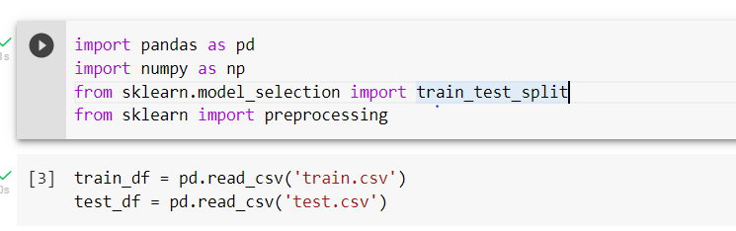

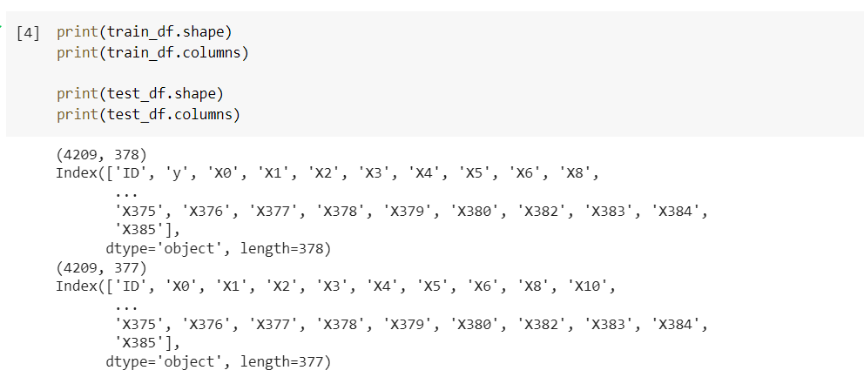

## Q2. If any column has the variance equal to zero, then you need to remove those variable and Check for null and unique values for test and train sets.

Step4: Check for null and unique values for test and train sets.  
train_df.isnull().sum().values  
train_df.isnull().any()  
test_df.isnull().sum().values

# Find unique records  
train_df.nunique()

Step5: Filter out the columns having object datatype

object_datatypes = train_df.select_dtypes(include=[object])

object_datatypes

object_datatype_columns = object_datatypes.columns

object_datatype_columns

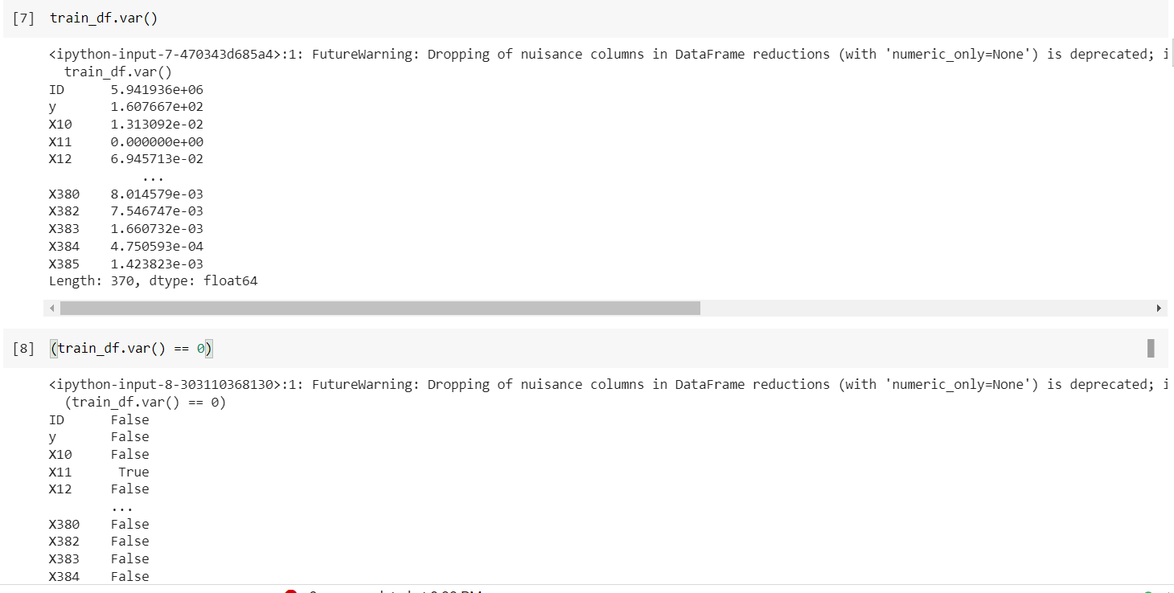

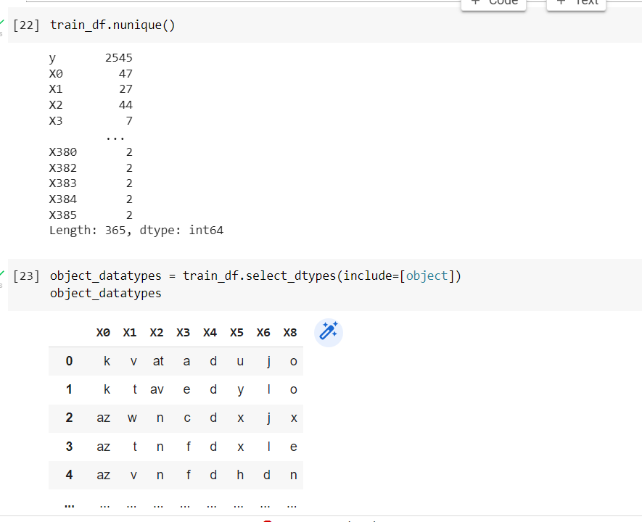

**Q3. Apply label encoder**

Step6: Apply label encoder.

label_encoder = preprocessing.LabelEncoder()

train_df['X0'].unique()

train_df['X0'] = label_encoder.fit_transform(train_df['X0'])  
train_df['X0'].unique()

# Apply same for all columns having object type data

train_df['X1'] = label_encoder.fit_transform(train_df['X1'])

train_df['X2'] = label_encoder.fit_transform(train_df['X2'])

train_df['X3'] = label_encoder.fit_transform(train_df['X3'])

train_df['X4'] = label_encoder.fit_transform(train_df['X4'])

train_df['X5'] = label_encoder.fit_transform(train_df['X5'])

train_df['X6'] = label_encoder.fit_transform(train_df['X6'])

train_df['X8'] = label_encoder.fit_transform(train_df['X8'])

train_df.head()

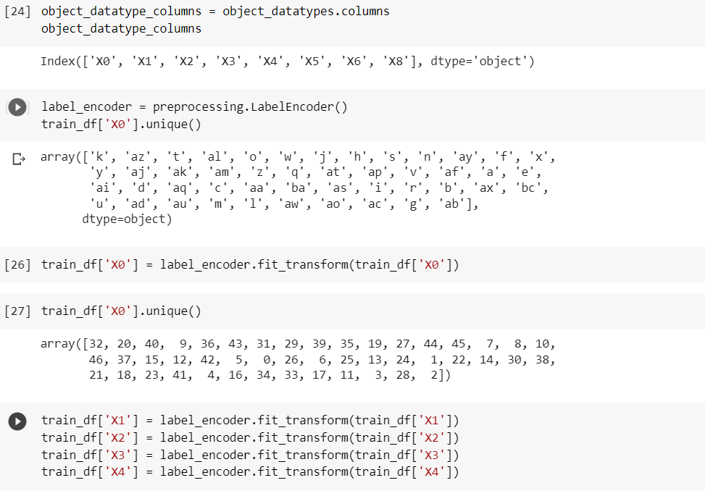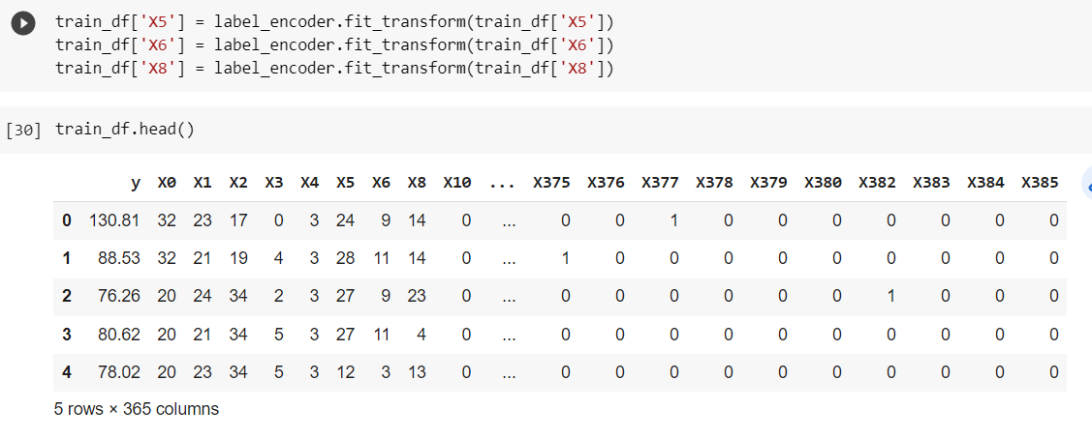

## Q4. Perform dimensionality reduction

Step7: Perform dimensionality reduction (PCA)

from sklearn.decomposition import PCA

sklearn_pca = PCA(n_components=0.95)

sklearn_pca.fit(train_df)

x_train_transformed = sklearn_pca.transform(train_df)

print(x_train_transformed.shape)

sklearn_pca_98 = PCA(n_components=0.98)

sklearn_pca_98.fit(train_df)

x_train_transformed_98 = sklearn_pca_98.transform(train_df)

print(x_train_transformed_98.shape)

train_df.y

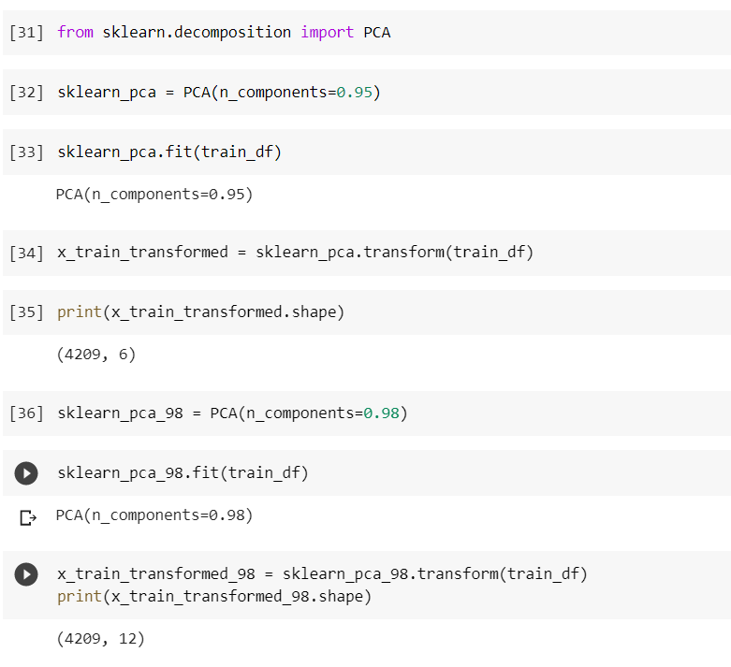

### **Q5. PCA for test_df dataset**

Step8: Train and Test split on Train dataset

X = train_df.drop('y', axis=1)

y = train_df.y

xtrain,xtest,ytrain,ytest = train_test_split(X,y,test_size=0.3,random_state=42)

print(xtrain)

print(xtrain.shape)

print(ytrain)

print(ytrain.shape)

print(xtest)

print(xtest.shape)

pca_xtrain = PCA(n_components=0.95)

pca_xtrain.fit(xtrain)

pca_xtrain_transformed = pca_xtrain.transform(xtrain)

print(pca_xtrain_transformed.shape)

pca_xtest = PCA(n_components=0.95)

pca_xtest.fit(xtest)

pca_xtest_transformed = pca_xtest.transform(xtest)

print(pca_xtest_transformed.shape)

print(pca_xtest.explained_variance_)

print(pca_xtest.explained_variance_ratio_)

Step9: PCA for test_df dataset

test_df

test_object_datatypes = test_df.select_dtypes(include=[object])

test_object_datatypes

test_df['X0'] = label_encoder.fit_transform(test_df['X0'])

test_df['X1'] = label_encoder.fit_transform(test_df['X1'])

test_df['X2'] = label_encoder.fit_transform(test_df['X2'])

test_df['X3'] = label_encoder.fit_transform(test_df['X3'])

test_df['X4'] = label_encoder.fit_transform(test_df['X4'])

test_df['X5'] = label_encoder.fit_transform(test_df['X5'])

test_df['X6'] = label_encoder.fit_transform(test_df['X6'])

test_df['X8'] = label_encoder.fit_transform(test_df['X8'])

print(test_df)

print(test_df.shape)

test_df = test_df.drop('ID',axis=1)

pca_test_df = PCA(n_components=0.95)

pca_test_df.fit(test_df)

pca_test_df_transformed = pca_test_df.transform(test_df)

print(pca_test_df_transformed.shape)

print(pca_test_df.explained_variance_)

print(pca_test_df.explained_variance_ratio_)

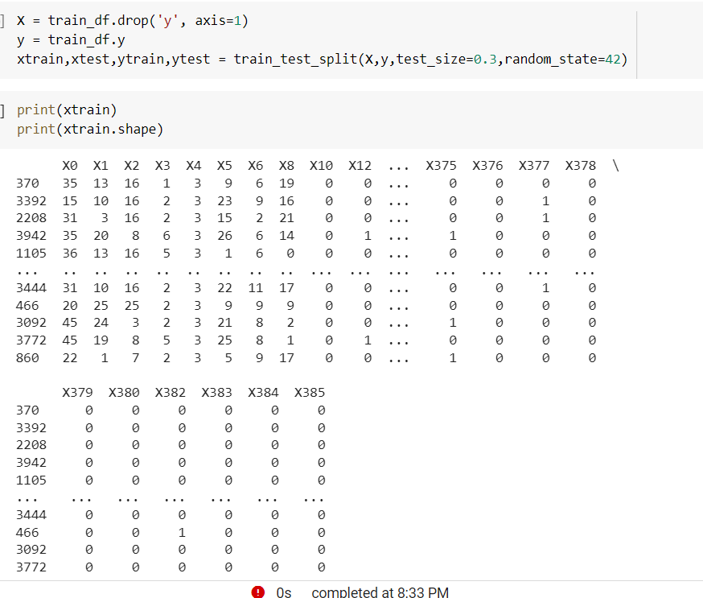

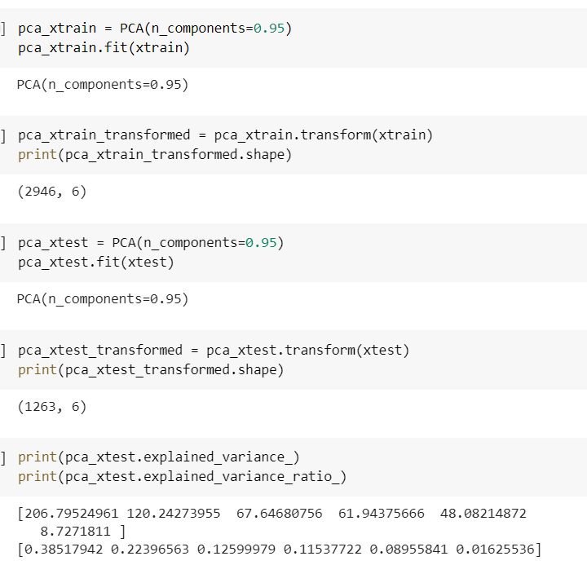

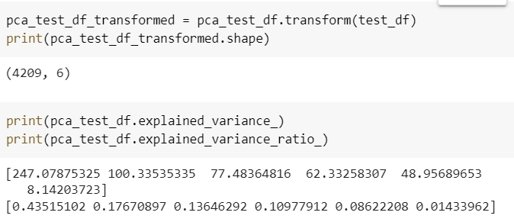

## Q6. Training using xgboost

Step10: Training using xgboost

test_df = pd.read_csv('test.csv')

usable_columns = list(set(train_df.columns) - set(['ID', 'y']))

ytrain = train_df['y'].values

id_test = test_df['ID'].values

xtrain = train_df[usable_columns]

xtest = train_df[usable_columns]

for column in usable_columns:

    cardinality = len(np.unique(xtrain[column]))

    if cardinality == 1:

# Column with only one value is useless so we drop it

        xtrain.drop(column, axis=1)

        xtest.drop(column, axis=1)

    if cardinality > 2:

# Column is categorical

        mapper = lambda x: sum([ord(digit) for digit in x])

        xtrain[column] = xtrain[column].apply(mapper)

        xtest[column] = xtest[column].apply(mapper)

xtrain.head()

Step11: Perform xgboost

import xgboost as xgb

from sklearn.metrics import r2_score

from sklearn.model_selection import train_test_split

xtrain, xvalid, ytrain, yvalid = train_test_split(xtrain, ytrain, test_size=0.2, random_state=4242)

d_train = xgb.DMatrix(xtrain, label=ytrain)

d_valid = xgb.DMatrix(xvalid, label=yvalid)

d_test = xgb.DMatrix(xtest)

params = {}

params['objective'] = 'reg:linear'

params['eta'] = 0.02

params['max_depth'] = 4

def xgb_r2_score(preds, dtrain):

    labels = dtrain.get_label()

    return 'r2', r2_score(labels, preds)

watchlist = [(d_train, 'train'), (d_valid, 'valid')]

clf = xgb.train(params, d_train, 1000, watchlist, early_stopping_rounds=50, feval=xgb_r2_score, maximize=True, verbose_eval=10)

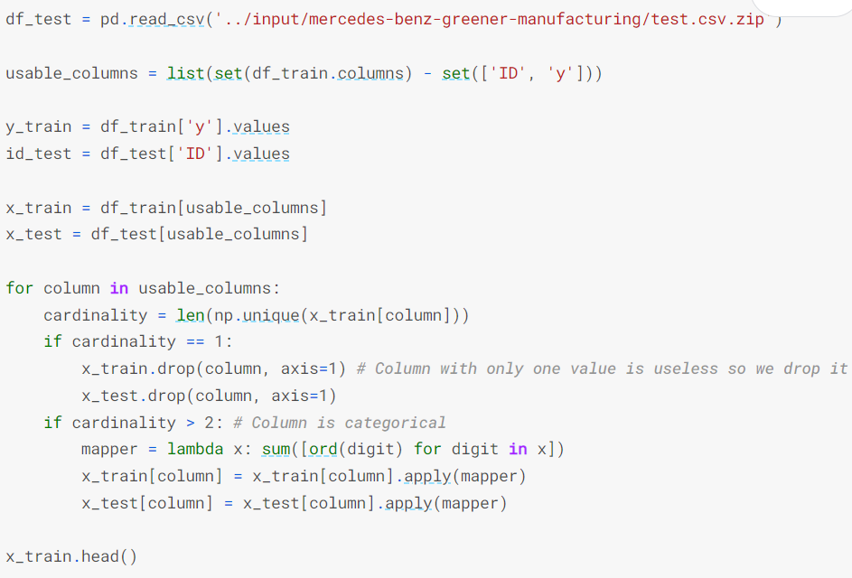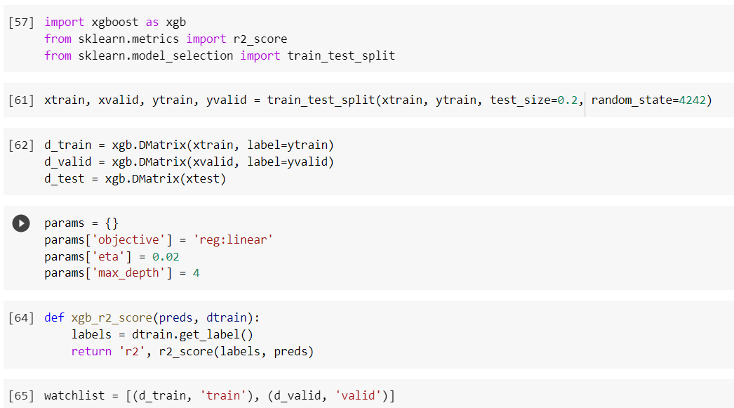

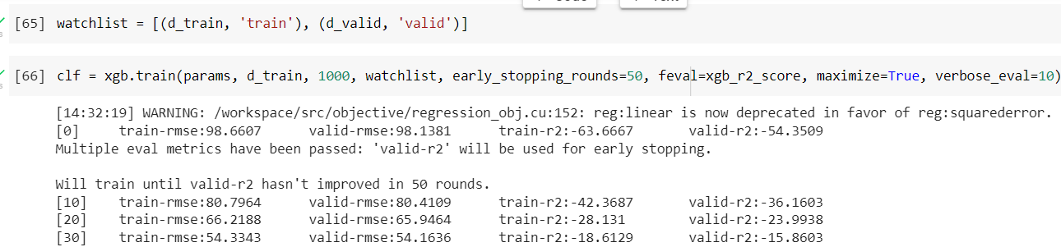

## Q7. Predict your test_df values using xgboost

Step12: Predict test_df values using xgboost.

p_test = clf.predict(d_test)

sub = pd.DataFrame()

sub['ID'] = ID

sub['y'] = p_test

sub.to_csv('xgb.csv', index=False)

sub.head()

